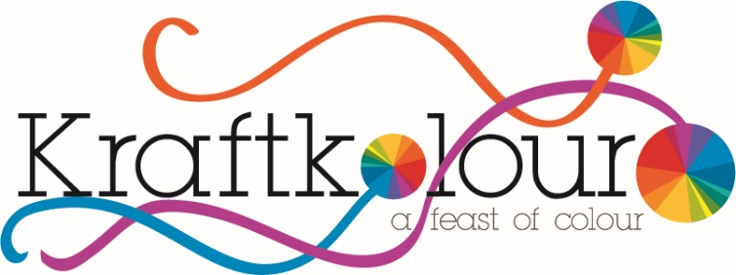
Kraftkolour
2/99 Heyington Ave
Thomastown 3074
Tel: 1300 720 493
Web: kraftkolour.net.au

FAQ’S – PACKAGING & MAILING MATERIALS

Wherever possible Kraftkolour uses recycled and compostable packaging and mailing materials.
Dye and chemical powders need to be packed in secure and unbreakable containers as a safety precaution which can mean plastic jars and bottles are necessary for safe delivery and transit.
We hope that you recycle and dispose of all our packaging with due respect for the environment.

Clear PET Bottles | Recyclable
Clear PET Jars | Recyclable
White Jars | Recyclable
White & Black Lids | Recyclable
Black Mail Bags | Compostable Corn
White Padded Bags | Enviro Bags made from recycled materials
Flow Pak Cheezels | Compostable Corn
Brown Recycled Cardboard Mailing Boxes | Recyclable/compostable
White Cardboard Boxes | Recyclabl /compostable
White Buckets | Recyclable
Lined Resealable Paper Pouches | Outer paper only compostable
Recycled White Wrapping Paper | Compostable/ recyclable

