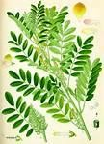
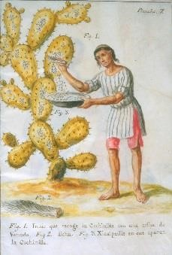
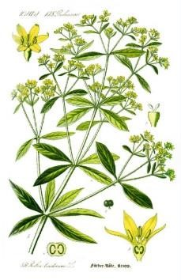
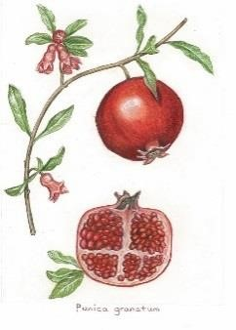
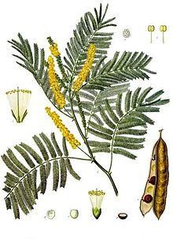
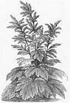

MORDANTING NATURAL DYES
Most natural dyes have great affinity for fibre but poor light and wash fastness. If the fibre is pre mordanted you create a bond between the dye and the fibre which will improve this dramatically. The most common and least environmentally toxic are Alum, Iron and Tannin.
Copper is a useful mordant but is toxic to marine life and humans. It needs to be handled and disposed of carefully. Historically Tin and Chrome have been used but are hazardous to the environment & your health and need to be disposed of with great care. For that reason we recommend only using Alum, Iron, Copper and Tannin. Copper is probably the least safe but will give you much brighter shades and is safe to use sparingly. Apart from improving the bonding of natural dyes to fibre, different mordants change the shade of each dye - both Copper and Iron are used in this way. Always wear gloves and work in a well ventilated space. Use only non reactive dyepots (Glass, Stainless Steel, unchipped Enamel). Using copper or Iron pots will change the shade of your dyes (which can be fun!) WOF = Weight Of Fibre

MORDANTS
ALUM (Potassium Aluminium Sulphate) is the most common mordant used on Protein (animal fibres) and Cellulose (plant fibres).It makes colours clearer, more light and washfast. Potash Alum is an inexpensive and safe chemical to use. It has a great affinity for Protein fibre but not so much with Cellulose so we use Tannin (which has a high affinity for cellulose) to help the bonding process. Use at 15% WOF.
ALUMINIUM ACETATE is used as an alternative to Potash Alum for cellulose fibres and fabrics. Using Aluminium Acetate as a mordant produces richer colours on cellulose It’s a more expensive mordant than Alum but well worth the results.
Use at 5 to 8% WOF.

Kraftkolour P/L 2/99 Heyington Ave Thomastown, Victoria, Australia 3074 info@kraftkolour.com.au ph: 94606432
Web: Kraftkolour.net.au

IRON SULPHATE (Ferrous Sulphate) is usually used to change the colour of a dye. It also makes natural dyes more light and wash fast. More often used with cellulose than protein as it can make protein fibres brittle and harsh. Iron changes shades to deeper, darker shades and is better used in a premordant bath than directly into the dyebath. Use at a maximum of 2 to 4 % WOF .
COPPER (Copper Sulphate)tends dull colours and turn them blue green ie. yellows become greens, pinks become purple. You can use Copper as a premordant or as an after treatment to adjust colours. Colours dyed with Copper are usually more lightfast than those dyed with Alum. Copper has a less harsh effect on Protein fibres than Iron. Dispose of Copper solution responsibly by exhausting your dyebaths, diluting the residue with clean water and don’t put it down the storm water. Use at 2 to 4% WOF.
TANNIN (Tannic Acid) Some dyes already contain
Tannin which eliminates the need for it to be used
when dyeing cotton. Fustic, Cutch, Myrobalan and
Pomegranate are 4 such dyes which will not need
Tannin in your premordant.
GALLNUTS (oak gall) are a source of clear
tannin. A gallnut is produced by oak trees as a reaction against parasitic wasps who deposit
their eggs in small punctures they make on
young branches. The tree excretes a tannin rich
substance that hardens and forms a gallnut.
These are collected and ground to be used in
dyeing. Use at 6-8% WOF.
MYROBALAN this dye consists of ground nuts of the Terminalia Chebula tree which grows in Nepal, India, Sri Lanka, Burma, Thailand, Indochina and south China. Myrobalan is both a tannin and a dye, giving warm soft gold yellow Myrobalan works well for overdyeing as well as a predye with Myrobalan under a pale Indigo dyeing to produce light teal greens. Use 15-20% WOF as a Tannin mordant and 20-30% WOF for a gold yellow.
CREAM OF TARTAR (potassium bitartrate) is obtained from the sediment produced in the wine making. Cream of tartar can be added to the dyebath to soften wool, brighten shades, and change the colour of some dyes (it will change the fuschia of cochineal to a pure red). Cream of tartar works best with protein fibres and is seldom used with plant or cellulose fibres. Use at 5-6% WOF.

MORDANTING WOOL and SILK WITH ALUM

- Use 15% WOF Alum (Aluminium Potassium Sulphate)
- Add 6% WOF Cream of Tartar (Optional)
- Dissolve Alum and Crème of Tartar in hot water in a stainless steel, glass or plastic container.
- Add to dyebath with enough warm water to cover the fibre. Stir well.
- Add wet fibre to and slowly bring to about 85c for 45 mins. Stir gently every now and again.
- Allow the fibre to cool in the bath then remove. Rinse well. If you’re not using it immediately, it can be stored for future use but should be wet before use.
- Premordanted dried fibre can be stored indefinitely.

MORDANTING CELLULOSE WITH ALUM and TANNIN
- Use 15% WOF Alum (Aluminium Potassium Sulphate)
- Use 6% WOF Tannin, dissolve in hot water and add to dye pot with enough warm water to cover fibre.
- Add wet fibre and bring to about 85c for 45 mins. Stir gently every now and then.
- Cool, remove and rinse well then mordant with dissolved Alum.
- ** If you allow the fibre to sit for 24 hours to steep in the Tannin, you will get much stronger colours from your dye.

